Physics 1135 Homework #1: Math review, 1-d Kinematics.

I. Math Review
1. Solve the system of equations for A:

$$7A - 5B = - 1$$
$$B + A = 5$$

2. Solve the equation $x^{2}+4x=96$.

L?
D=?
θ
S
3. For the right triangle in the figure, express the lengths D and L
in terms of S and the angle θ.

L
x=?
θ
4. The figure shows two similar right triangles.
Express the length x in terms of L and θ.

5. Calculate the derivative of $f(x)$ with respect to $x$ for the following functions:
a) $f(x)= 2x^{-3}$
b) $f(x) = 2x sin(5x^{2})$

6. Calculate the indefinite integral ∫ f(x) dx for the following functions:
a) $f(x)=\frac{1}{x^{2}}$

b) $f(x)= x^{7}$

II. 1-d Kinematics: Relationship between position, velocity, and acceleration
1. A particle is moving along the x-axis. Its position as a function of time is given as
$x=bt-ct^{2}$.
a) What must be the units of the constants b and c, if x is in meters and t in seconds?
b) At time t=0, the particle is at the origin x=0. At what later time t does it pass the origin again?
c) Derive an expression for the x- component of velocity, v_{x}.
d) At what time t is the particle momentarily at rest?
e) Derive an expression for the x-component of the particle’s acceleration, a_{x}.

2. A particle is moving along the x-axis. Its acceleration as a function of time is given by
$a_{x}=ct-dt^{2} .$ At t=0, the particle is at rest at the origin.
a) Derive equations for position and velocity as functions of time.
b) What is the maximum velocity the particle reaches?
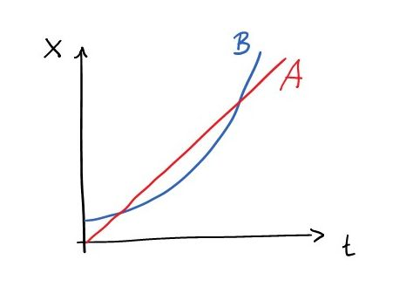
3. The figure shows position vs time graphs for two horses.
a) Sketch velocity vs time graphs for each of the horses.
b) Do the horses ever have the same speed? Where?
c) Does horse A ever passes horse B? If so, indicate at which point in time.
d) Does horse B ever passes horse A? If so, indicate at which point in time.

