Physics 1135: Homework #10: Work and Work-Kinetic Energy-Theorem
1. A crate of mass 5kg is pushed up a rough incline by means of a horizontal pushing force of constant magnitude 50N. The incline makes an angle 30° with respect to the horizontal and has a coefficient of kinetic friction 0.2 with the surface of the crate. The crate moves a distance 3m along the incline. Derive symbolic expressions and calculate numerical values for
a) the work done on the crate by gravity.
b) the work done on the crate by the pushing force.
c) the work done on the crate by the normal force.
d) the work done on the crate by friction.
e) the final speed of the crate if the crate started from rest (use the work-kinetic energy- theorem).

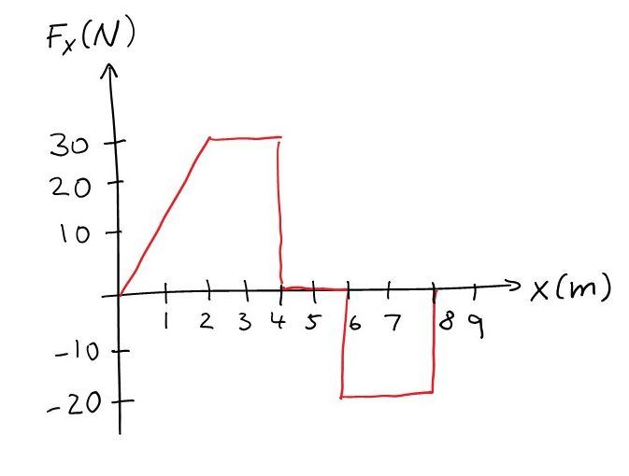
2. A block of mass 2kg is moving along the x-axis under the influence of a force whose x-component varies as shown in the graph. The particle is at rest when it is at the origin.
Determine the work done by the force as the block moves
a) from x=0 to x= 4m
b) from x=0 to x=8m
Find
c) the speed of the block at x= 4m.
d) the speed of the block at x= 8m.
(Hint: geometric interpretation of the integral.)

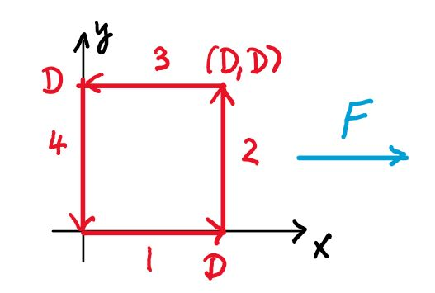
3. A position-dependent force acting on an object is given as $\vec{F}=cxy\hat{i}$ where c is a positive constant. The object moves along a path consisting of four steps, as shown in the figure:
1. from the origin along the x-axis to the point (D,0);
2. parallel to the y-axis to the point (D,D);
3. parallel to the x-axis to the point (0, D);
4. along the y-axis back to the origin.
For each of the steps, calculate the work done by the force on the object.

4. For use in the St. Pat’s Parade, students have built a cart of mass M with an engine that can propel it with a non-constant force. They launch the cart on a frictionless horizontal surface from rest. While the surface is horizontal, the cart’s engine provides a force F(x)=F_{o}+cx³ in the direction of the cart’s motion, where x is the distance traveled, and F_{o} and c are positive constants. Due to a design flaw, the engine stops working after the cart has traveled a distance D, as soon as the cart encounters a frictionless incline that makes an angle θ with the horizontal.
D
H
θ
F
0
x
Use the Work-Kinetic Energy Theorem to derive an expression for the speed of the cart when it has reached a vertical height H above the starting point.

