Physics 1135: Homework #11: Potential energy
1. In an amusement park ride, a car rolls on the frictionless track depicted in the figure. It starts from rest at height H above the ground. Find the minimum value for H necessary so that the car moves around the circular loop of radius R without falling off. Treat the car as a point mass and express H in terms of R.
H
R

L
M
B
C
RA flat puck is moving in a circle on a horizontal frictionless table. It is held in its orbit by a string. The puck takes one second to complete a full circle. The tension in the string equals 6N. If the puck went around one circle in two seconds, what would be the tension in the string?
A) 1.5N B) 3N C) 12N D) 24N

A
dA flat puck is moving in a circle on a horizontal frictionless table. It is held in its orbit by a string. The puck takes one second to complete a full circle. The tension in the string equals 6N. If the puck went around one circle in two seconds, what would be the tension in the string?
A) 1.5N B) 3N C) 12N D) 24N

P
rough

2. A small block of mass M is released from rest at point A at the top of a frictionless quarter-circular slide of radius R. It slides down to point B and across a rough horizontal surface. After sliding a distance L to point C, the block encounters a spring of spring constant k, and compresses it a distance d before coming to rest at point P. The surface is rough all the way from point B to point P.
Derive an expression for the coefficient of kinetic friction between the floor and the block, in terms of relevant system parameters.
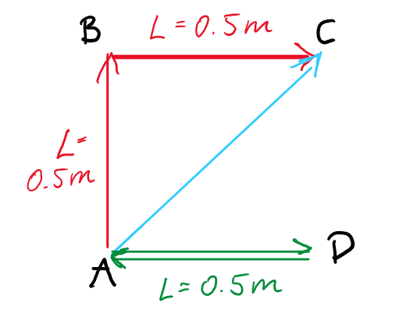
3. A 2kg box is sliding along a horizontal table. The coefficient of kinetic friction between box and table is 0.3. The figure shows a top view of the table. Calculate the work done by friction on the box when it slides
a) from A straight to B and then to C (red path).
b) from A directly to C (blue path).
c) from A straight to D and then straight back to D (green path).
d) Based on the results of your calculation, is kinetic friction a conservative force or not?

4. A block of mass m is on a rough incline that makes an angle θ with the horizontal. The coefficient of kinetic friction between the block and the incline is μ. A light string connects it to another block of mass M that hangs over a frictionless pulley as shown. The block on the incline is attached to a spring of spring constant k whose other end is secured to a wall at the lower end of the incline. The blocks are released from rest with the spring in equilibrium position. Their masses are such that the block of mass M moves downward as it pulls the block of mass m up the incline, stretching the spring.
m
M
θ
k

Derive an expression for the speed of the blocks when they have traveled a distance H, in terms of system parameters.

