Physics 1135: Homework #12: Potential energy methods
1. a) The potential energy of a conservative force is given by $U(x,y)=A\left(\frac{1}{x}+\frac{1}{y}\right)$ where A is a constant. Find the corresponding force vector $\vec{F}(x,y)$ in unit vector notation.
b) A force is given as $\vec{F}=C\sin{kx}\hat{i}$ . Derive an expression for a potential energy associated with this force, with the reference point at x=0 with a value U(x)=0.
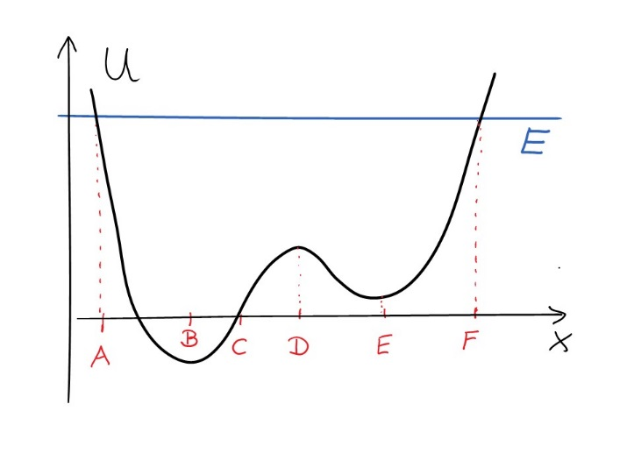
2. A particle with total mechanical energy E is moving along the x-axis under the influence of a conservative force whose potential energy is shown in the figure.
a) At which of the points is the particle momentarily at rest?
b) At which points is the force on the particle zero?
c) At which point does the particle have its largest kinetic energy?
d) At which points is the fore directed to the left? To the right?

3. A student has built a cart of mass M with an engine that can propel it with a non-constant force. He launches the cart on a horizontal surface from rest. While the surface is horizontal, the cart’s engine provides a force F(x)=cx², proportional to the square of the distance x traveled, in the direction of the cart’s motion (c is some positive constant). Due to a design flaw, the engine stops working after the cart has traveled a distance L as soon as the cart encounters an incline that makes an angle θ with the horizontal. The cart continues up the slope until it stops. Throughout the entire motion, a constant horizontal blowing force of magnitude B is acting on the cart.
L
H
θ
F
0
x
B

Derive an expression for the vertical height H the cart has gained above the starting point when it comes to rest, in terms of system parameters.

4. The potential energy associated with the force between two atoms can be modeled as
$$U\left(r\right)=\frac{A}{r^{12}}-\frac{B}{r^{6}}$$
where A and B are positive constants.
a) Qualitatively sketch the potential energy as a function of r.
b) Derive an expression for the component of the force on each atom, F_{r}.
c) Find the equilibrium separation r_{eq}.
d) Calculate the dissociation energy, i.e. the energy required to separate the two atoms from their state of lowest energy to r=∞.

