Physics 1135 Test 2 Preparation Homework
1. A box of mass M is on a rough incline that makes an angle θ with the horizontal. The coefficient of kinetic friction between the box and the incline is µ. The box is placed against a spring whose other end is secured to a wall at the lower end of the incline. The block is used to compress the spring a distance D and is then released from rest.
μ
D
θ
L
M
Derive an expression for the minimum spring constant k necessary to ensure that the box reaches a distance L up the incline from the equilibrium position of the spring. (Treat the box as a point mass.)

2. A star cruiser of mass 5M and travelling in the positive y-direction at speed Vis in transit halfway between The Milky Way and Galaxy NGC 300. Due to an existential flaw in the dilithium crystals used as fuel, the star cruiser explodes into three fragments. One fragment of mass 2M moves in the positive x-direction with speed 2V. The second fragment of mass M moves in the positive y-direction with speed 8V. The third fragment moves in an unknown direction.

a) In the diagram add all information to solve part b below.
Before After
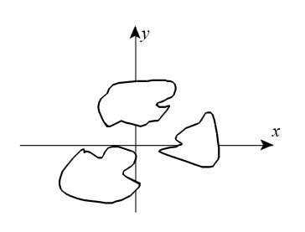

b) Derive an expression for the velocity of the third fragment, in terms of system parameters. Express the velocity in unit vector notation.

3. a) A projectile of mass m is shot directly away from the surface of a planet of mass M and radius R with an initial speed that equals ½ the escape speed from the planet. Derive an expression for the maximum distance from the center of the planet the projectile reaches, in terms of R.
R
2R
M
m
b) A satellite of mass m is put into a circular orbit around the planet of mass M and radius R. It orbits a distance 2R above the planet’s surface. Derive an expression for total mechanical energy E of the satellite, in terms of G, m, M and R.

.

