Physics 1135: Homework for Recitation #22: Static Equilibrium

1. A uniform horizontal beam of length L and weight W is attached to a wall at its base by pivot P. The other end of the beam is supported by a cable that makes an angle θ with the vertical wall, as shown. A person of weight 2W stands on the beam at a distance ¾ L from the wall.
W
T
θ
P
L
a) Complete the diagram on the right with all information necessary to solve parts b) and c) below.
b) Derive an expression for the tension the cable in terms of relevant system parameters by taking the torques about the pivot P.
c) Derive expressions for the horizontal and vertical components of the support force that the pivot exerts on the beam in terms of relevant system parameters. You may treat the tension T in the cable as a system parameter for this part.

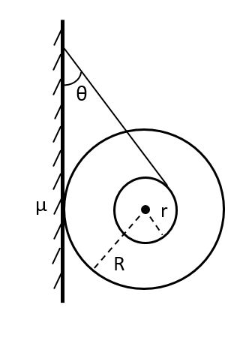
2. A yoyo consists of a small axle of radius r and two larger disks of radius R. A thread is wound around the yoyo’s axle, and the other end is attached to a nail on the wall, so that the yoyo is hanging below it, as shown on the figure. The coefficient of static friction between the wall and the yoyo is μ.
a) Complete the diagram with all information necessary to solve part b) below.
b) In terms of system parameters, derive an expression for the minimum value of the angle θ for which the yoyo remains in static equilibrium. (Hint: calculate the torques with respect to the center of mass.)

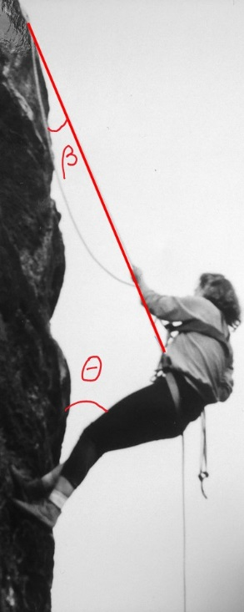
3. A physics professor of mass 58kg and height 1.68m is rappelling down a vertical cliff when she pauses for a moment. Her feet are touching the cliff, and she is leaning back so that her body makes an angle θ=40° with the vertical. She is tied into a harness that is connected to a rope that makes an angle of β= 20° with the cliff face. The tension in the rope has a line of action that goes through her center of mass which is 1.0 m from her feet. Her hands are not exerting a force on the rope (it is fed through a figure eight shaped braking device that exerts the necessary tension).
a) Find the minimum coefficient of static friction between her feet and the cliff so that her feet do not slip on the cliff wall. (Hint: begin with the sum of torques about the center of mass).
b) Find the tension in the rope if her feet are about to slip and the coefficient of static friction has the value you obtained in part a).

4. A stationary ladder of length L and mass M leans against a smooth vertical wall, while its bottom legs rest on a rough horizontal floor. The coefficient of static friction between floor and ladder is µ. The ladder makes an angle θ with respect to the floor. A painter of mass ½M stands on the ladder a distance d from its base.
L
d
M
½M
θ
Derive an expression for the largest value of d for which the ladder does not slip.

