Physics 1135: Homework for Recitation #29: First Law of Thermodynamics
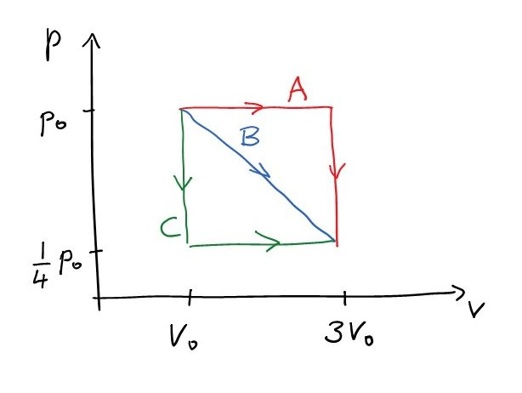
1.
2.5 moles of an ideal monatomic gas at an initial pressure p₀=60 kPa and volume of V₀=0.1m³ are expanding to three times the initial volume by means of three different processes shown in the diagram. Process A consists of first an isobaric and then an isochoric section. Process C consists of first an isochoric and then an isobaric section. During Process B, the pressure-volume relationship is linear.
a) Determine the initial and final temperature of the gas.
b) For each of the processes, find the work done by the gas.
c) For each of the processes, find the change in internal energy.
d) For each of the processes, find the heat flowing into the gas. (Hint: For process B, you should use the 1st Law of Thermodynamics.)

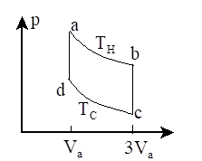
2. Stirling Cycle.
A diatomic ideal gas (n moles) goes through cycle a-b-c-d-a as shown in the figure. Processes ab and cd are isothermal and occur at temperatures T_{H} and T_{C}, respectively.
For each of the four processes, calculate the work done by the gas, the heat energy flowing into the gas, and the change in internal energy.

3. An ideal gas is initially at a certain pressure and volume. It expands until its volume is four times the initial volume. This is done through an isobaric, an isothermal, and an adiabatic process, respectively. During which of the processes ….
a) …is the work done by the gas greatest?
b) … is the smallest amount of work done by the gas?
c) … does the internal energy increase?
d) …does the internal energy decrease?
e)… does the largest amount of heat flow into the gas?
Hint: You may want to sketch a p-V diagram.

