Fall 2023 Physics 1135 Print LAST Name:
Rec Sec Number TEST 1 (4 pages) and First Name:

Test Total = 200 / 200
For questions on this page, write the letter which you believe to be the best answer in the underlined space provided to the left of the question number. For problems on subsequent pages: your solution to a question with OSE in front of it must begin with an Official Starting Equation. The expression for the final result must be in system parameters and simplified as far as possible. Draw a box around your answer to each question. Neglect air resistance. Calculators and notes cannot be used during the test. If you have any questions, ask the proctor. You must put your name on each page of the test.
__D___1. (10 points). A child throws a ball at 30º above the horizontal. When the ball reaches its maximum height,
A) its acceleration and speed are both zero.
B) its acceleration is zero, but its speed is not zero.
C) its speed is zero, but its acceleration is not zero.
D) its acceleration and speed are both not zero.
__D__ 2. (10 points) The $y$-component of an object’s position is given as a function of time by
$y\left(t\right)=a+bt^{2}-ct^{3}$where $a$, $b$, and $c$ are positive constants. What can be said about the position, velocity, and acceleration in the $y$-direction at time $t=0$?
A) $y=0$, $v_{y}=0$, and $a_{y}<0$ B) $y>0$, $v_{y}<0$, and $a_{y}>0$
C) $y>0$, $v_{y}=0$, and $a_{y}=0$ D) $y>0$, $v_{y}=0$, and $a_{y}>0$

_C___ 3. (10 points) A block of mass $M$ is resting on an inclined plane which forms an angle $θ$ with the horizontal. Which of the following is true about the magnitude of the normal force?
A) $N=Mg$ B) $N>Mg$ C) $N<Mg$ D) There is no normal force acting on the block.

_B___ 4. (10 points) A block of mass $m$ is pulled at a constant velocity $v$ along a surface with kinetic coefficient of friction $μ_{k}$ by a rope that makes an angle $θ$ above the horizontal. If the magnitude of the tension force acting on the block by the rope is T, which of the following is true?
m
x
θ
µ_{k}
y
A) $μ_{k}mg=T$ B) $ΣF_{x}=0$
C) $μ_{k}mg=T\cos{θ}$ D) $ΣF_{y}=mg$

_A_____5. (10 points) A particle rotates in a circle with centripetal acceleration a. If the period is doubled without changing the radius, the new acceleration will be
A) ¼ a B) ½ a C) 2 a D) 4 a

/ 50 for this page
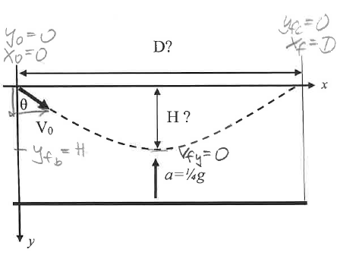
Name:_ ________________________

6. Students shoot a plastic ball into a container filled with a dense frictionless fluid. The ball enters the fluid with speed V_{o} at an angle θ with respect to the vertical wall of the container. While the ball is in the fluid, it has a constant upward acceleration of magnitude of ¼ g due to buoyancy. It reaches a maximum depth after which it comes to the surface again along the path shown.
Use the mandated coordinate system.
a) (10 points) Complete the diagram with all information needed to solve parts b and c below.
b) (20 points) Derive an expression, in terms of system parameters, for the maximum depth H the ball reaches.
$$\begin{matrix}v_{y}^{2}=v_{0}^{2}+2a_{y}{\left(y-y_{0}\right)}^{2} \\ 0={\left(v_{0}cos⁡θ\right)}^{2}+2\left(-\frac{1}{4}g\right)H \\ H=\frac{2{\left(v_{0}\cos{θ}\right)}^{2}}{g} \\ OR: v_{y}=v_{0y}+a_{y}t \\ 0=v_{0}cos⁡θ-\frac{1}{4}gt \\ 0={\left(v_{0}cos⁡θ\right)}^{2}+2\left(-\frac{1}{4}g\right)H \\ t=\frac{4v_{0}cos⁡θ}{g} \\ y=y_{0}+v_{0y}t+\frac{1}{2}a_{y}t^{2} \\ H=v_{0}\cos{θ\left(\frac{4v_{0}\cos{θ}}{g}\right)}-\frac{1}{2}\frac{g}{4}{\left(\frac{4v_{0}\cos{θ}}{g}\right)}^{2}=\frac{2{\left(v_{0}\cos{θ}\right)}^{2}}{g}\end{matrix}$$
c) (20 points) Derive an expression, in terms of system parameters, for the horizontal distance D after which the ball returns to the surface.
$\begin{matrix} & x=x_{0}+v_{0x}t+\frac{1}{2}a_{x}t^{2} \\ & D=v_{0}sin⁡θt \\ & \end{matrix}$
$$\begin{matrix}y=y_{0}+v_{0}t+\frac{1}{2}a_{y}t^{2} \\ 0=v_{0}cos⁡θt+\frac{1}{2}\left(-\frac{1}{4}g\right)t^{2} \\ t=\frac{8v_{0}cos⁡θ}{g} \\ D=\frac{8v_{0}^{2}sin⁡θcos⁡θ}{g}\end{matrix}$$
OR: if found $t$ in $b$ ), use twice $t$
Name:_________________________
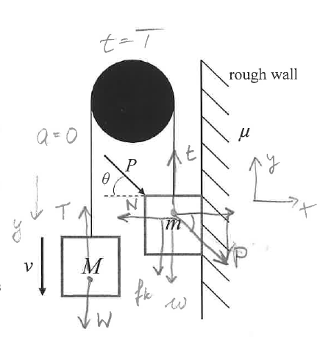
7. (50 points) A block of mass m moves up a rough vertical wall. The coefficient of kinetic friction between the block and the wall is μ. The block is connected to a hanging block of mass M by a massless string passing over a massless frictionless pulley. An external force of constant magnitude P retards the motion by pushing the block at an angle θ with the horizontal; the block maintains contact with the surface of the wall at all times. Block M moves down at a constant speed v.
a)(10 points) In the figure, superimpose free-body diagrams for each block containing all information needed to solve part b.
b)(OSE) (40 points) Derive an expression for the value of P for which the blocks move at a constant speed, in terms of relevant system parameters.
$$\begin{matrix} & \begin{matrix}M:\sum{ }F_{y}=T_{y}+ω_{y}=Ma_{y} \\ -T+Mg=0 \\ T=Mg \\ \sum{F_{y}}=t_{y}+P_{y}+ω_{y}+f_{ky}+N_{y}=ma_{y} \\ t-P\sin{θ}-mg-f_{k}=0 \\ f_{k}=μN \\ \sum{F_{x}}=t_{x}+P_{x}+D_{x}+f_{kx}+N_{x}=ma_{x} \\ Pcos⁡θ-N=0⇒N=Pcos⁡θ\end{matrix} \\ & Combine: \\ & \begin{matrix} & Mg-Psin⁡θ-mg-μPcos⁡θ=0 \\ & Mg-mg=Psin⁡θ+μPcos⁡θ \\ & Mg-mg=P(sin⁡θ+μcos⁡θ)\end{matrix} \\ & P=\frac{(M-m)g}{sin⁡θ+μcos⁡θ} \\ & \\ & \end{matrix}$$

/ 50 for this page
Name:________________________________________
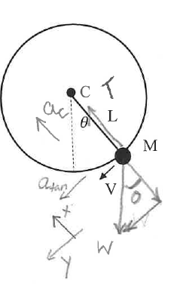
8. (50 points) A ball of mass M is attached to a string of length L whose other end is attached to point C. The ball is moving in a vertical circle about C. At a certain instant of time, the speed of the ball is V and the angle between the string and the vertical is θ.
a) (10 points) Complete the diagram with all information needed to solve parts b and c below.
b) (25 points) Derive an expression for the tension in the string at the moment shown in the diagram, in terms of system parameters.
$$\begin{matrix}\sum{F_{x}}= & T_{x}+W_{x}=Ma_{x} \\ & T-Mgcos⁡θ=M\frac{v^{2}}{L} \\ & T=Mgcos⁡θ+M\frac{v^{2}}{L} \\ & T=M\left(gcos⁡θ+\frac{v^{2}}{L}\right)\end{matrix}$$

c) (15 points) In terms of system parameters, derive an expression for the rate at which the ball’s speed changes, i.e. dv/dt, at this instant.

$$\begin{matrix} \\ \frac{dv}{dt}=a_{tan}=a_{y}⇒\sum{ }F_{y}=T_{y}+ω_{y}=Ma_{y} \\ Mgsin⁡θ=Ma_{y} \\ \frac{dv}{dt}=a_{y}=gsin⁡θ\end{matrix}$$

/ 50 for this page

