Physics 1135 Version A

Fall 2024 Answer Sheet Print LAST Name:
Rec Sec______ EM Mini-Test First Name:
& Final Exam
Remove this page from your exam when you begin. Write clearly in the space provided on this Answer Sheet the letter which you believe to be the best answer to each question.
.
ONLY THIS ANSWER SHEET will be looked at for scoring. Make sure your chosen answers are on it and do not leave any answer space blank.
Neither calculators nor notes can be used during the test.

Final-Exam Score =

EM Mini-Test Score =

Mini-Test Responses (10 pts each) Final-Exam Responses (10 pts each)

Em - 1) 1) 11)
Em - 2) 2) 12)
Em - 3) 3) 13)
Em - 4) 4) 14)
Em - 5) 5) 15)
Em - 6) 6) 16)
7) 17)
8) 18)
9) 19)
10) 20)

End-Material Mini Test
Em-1. A transverse traveling wave on a string is described by the equation $y\left(x,t\right)=A\sin\left(kx-ωt\right)$, where all constants are positive. The wave is traveling in the _______ $x$-direction and a bit of string at $x=0$, $t=0$ is moving in the _________ $y$-direction.

A) positive/positive B) positive/negative C) negative/positive D) negative/negative

Em-2. A guitar string of length $L$ has been tightened to a specific level of tension $T$ to vibrate at its fundamental frequency $f$. To what tension $T'$ should the string be tightened so that its new fundamental frequency doubles?

A) $T^{'}=4T$ B) $T^{'}=2T$ C) $T^{'}=T/2$ D) $T^{'}=T/4$

Em-3. You have hot water of a mass M initially at 80°C. You add ice, initially at 0°C, to bring the mixture to 20°C. Which of the following is a correct expression for the mass of ice you must add? (Ignore the container)

A) $M\frac{C_{Water}×60°C}{C_{Water}×20°C+L_{ice}}$ B) $M\frac{C_{Water}×60°C}{C_{ice}×20°C+L_{ice}}$

C) $M\frac{C_{Water}×60°C}{C_{ice}×20°C}$ D) $M\frac{C_{Water}×60°C}{L_{ice}}$

A
B
D
C
2P₀
P₀
V₀
2V₀
Problem 4 and 5 refer to the cycle in the figure at the right.

Em-4. An ideal monatomic gas is going through the cycle ABCDA in the p-V diagram. What is the the change of the internal energy during the process A-B?
A) $2P_{0}V_{0}$ B) $3P_{0}V_{0}$ C) $4P_{0}V_{0}$ D) $-2P_{0}V_{0}$

Em-5. An ideal monatomic gas is going through the cycle ABCDA in the p-V diagram. The net heat flowing into the gas during the cycle equals

A) $2P_{0}V_{0}$ B) zero C) $P_{0}V_{0}$ D) $-2P_{0}V_{0}$

Em-6. When the temperature of an ideal gas increases, we can conclude that:

A) its pressure increases B) its volume increases
C) the work it does is positive D) its internal energy increases

Final Exam
Ignore air resistance for all problems.

1. A cannonball is fired from a castle wall at some height above the ground, with an initial velocity directed at 30° above the horizontal. It hits the level ground some horizontal distance from the wall. Which of the following is true about the cannonball?
A) Its velocity is zero at the highest point of the trajectory.
B) Its acceleration decreases up to the highest point, and then increases during the downward motion.
C) It hits the ground with a speed that equals the initial speed.
D) The horizontal velocity component when it hits the ground equals the initial horizontal velocity component.

2. The position of an object in one dimensional motion as a function of time t is given by x(t) = q – bt² + ct³ where q, b, and c are positive constants. At t = 0, the object’s position, velocity component and acceleration component are:
A) x = 0 , v_{x} = b , and a_{x} = 0 B) x = q , v_{x} = 0 , and a_{x} = c
C) x = q , v_{x} = –b , and a_{x} = 0 D) x = q , v_{x} = 0 , and a_{x} = –2b

a
L
θ
3. A model car is at rest at the bottom of an incline which makes an angle θ with horizontal. It is then accelerated along the incline with a constant acceleration a. If the total length of the incline is L, how long does it take for the car to reach halfway on the incline?

A) (L/a)^{1/2} B) (L/2a)^{1/2} C) (L/[a cosθ])^{1/2} D) (L/[2a cosθ])^{1/2}

4. A ball rests on the table. The reaction force to the ball’s weight is
A) the normal force acting on the ball B) the normal force the ball exerts on the table
C) the gravitational force of the ball on the Earth D) there is none, because the ball is at rest

5. A box of mass M is pushed by a horizontal pushing force of magnitude P up a frictionless incline that makes an angle θ with the horizontal. The box speeds up as it is moving up the incline. The acceleration magnitude of the box is
θ
Moving up
M
P
A) g − P/M B) P cos θ/M
C) (P cos θ + Mg sin θ)/M D) (P cos θ − Mg sin θ)/M

6. A block is sliding to the right on a flat rough surface but is changing its speed. The direction of the force of friction exerted on the block by the surface is:
A) to the right B) to the left C) depends on the direction of acceleration
D) opposite to the direction of the sum of other applied forces

7. A particle with speed V is undergoing uniform circular motion with period T. If the period is halved while the radius remains unchanged, what is the ratio of the new centripetal acceleration to its original value?
A) 1/4 B) 1 C) 2 D) 4

8. The work done by a force on an object is zero if the force is
A) constant. B) perpendicular to the displacement.
C) conservative. D) parallel to the displacement.
9. The potential energy of a conservative force is given by $U(x,y)=A\left(\frac{1}{x^{2}}+\frac{1}{y^{2}}\right)$ where A is a constant. The corresponding force vector $\vec{F}(x,y)$ equals
A) $A\left(\frac{1}{x}\hat{i}+\frac{1}{y}\hat{j}\right)$ B) $-A\left(\frac{1}{x}\hat{i}+\frac{1}{y}\hat{j}\right)$ C) $2A\left(\frac{1}{x^{3}}\hat{i}+\frac{1}{y^{3}}\hat{j}\right)$ D)$-2A\left(\frac{1}{x^{3}}\hat{i}+\frac{1}{y^{3}}\hat{j}\right)$

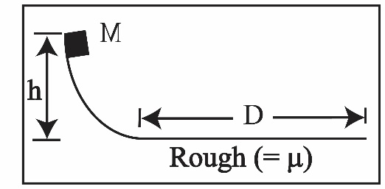
10. A crate of mass M is released from rest at the top of a frictionless curved path. Once it reaches the bottom, it encounters a rough surface and slides a horizontal distance D before coming to rest. The coefficient of friction μ between the crate and the rough surface is
A) $\sqrt{\frac{h}{gD}}$ B) $\frac{h}{D}$ C)$\sqrt{\frac{2h}{gD}}$ D) $\frac{D}{2h}$

11. An object of weight W has a density three time the density of water. It is hung from a vertical spring force scale and lowered into water. When the object is fully submerged, the reading on the scale is:
A) $\frac{1}{3}W$ B)$\frac{1}{2}W$ C)$\frac{2}{3}W$ D)$W$

12. The escape speed from a planet of mass M and radius 2R is
A) (GM/2R)^{½} B) (GM/R)^{½} C) (GmM/R)^{½} D) (GM/R²)^{½}

13. A massless spring of force constant k is compressed a distance D between two identical airtrack carts, each of mass M. The carts are at rest and a small latch keeps them together on a frictionless air track. When the latch is released, the final total momentum of the system is:
A) zero B) kD² C) $\sqrt{2Mk}D$ D) 2(kD²/M)
2M
2M
M
½V
V
θ
y
x
2
1
3
14. A firecracker of mass 5M which was initially at rest explodes into three fragments. Fragment 1 of mass M moves in the positive x-direction with speed ½V. Fragment 2 of mass 2M moves with speed V at an angle θ left of the positive y-axis as shown in the figure. Fragment 3 has mass 2M. The y- component of the velocity of fragment 3 equals:
A) V (sin θ - ¼ ) B) V (2 sin θ + ½)
C) −2 V sinθ D) − V cos θ

15. A rotating carousel has a horse near the outer edge and a unicorn halfway out from the center. Which of the following is true?
A) Both animals have the same angular velocity.
B) The horse has a larger angular velocity than the unicorn.
C) The unicorn has a larger linear velocity than the horse.
D) Both animals have the same linear velocity.
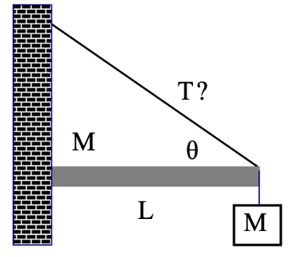
16. A stationary horizontal bar of mass M and length L is attached to a wall at its left end and is supported by a cable at its right end. The cable makes an angle θ with respect to the horizontal. A block with the same mass as the bar is hanging from the right end. The magnitude of the tension in the cable is
A) 2Mg/sin θ B) 3MgL C) 3Mg/(2cos θ) D) 3Mg/(2sin θ)

17. A star of mass M and radius $R_{1}$ (the moment of inertia of a solid sphere about its center of mass is $I=\frac{2}{5}MR^{2}$) rotates counterclockwise at an angular speed $ω_{1}$and suddenly collapses into a substantially denser star that has the same mass but radius $R_{2}$. This denser star is rotating counterclockwise at an angular speed $ω_{2}$
- $ω_{2}=ω_{1}(R_{1}/R_{2})^{2}$ B) $ω_{2}=ω_{1}(R_{1}/R_{2})$
C) $ω_{2}=ω_{1}(R_{2}/R_{1})^{2}$ D) $ω_{2}=ω_{1}\sqrt{R_{1}/R_{2}}$

18. Which of the following is a requirement for angular momentum conservation?
A) The net force on the body is zero.
B) The net momentum of the body is zero.
C) The net external torque on the body is zero.
D) All internal torques are conservative.

19. An object is undergoing simple harmonic oscillations with amplitude A. At what displacement from the equilibrium position does its kinetic energy equal three times its potential energy?
A) ⅓A B) ½A C) ⅔A D) A

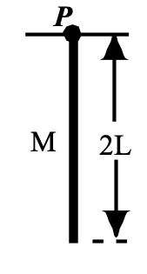
20. A rod of mass M and length 2L is pivoted at P and performs small oscillations in a vertical plane. What is the period for small oscillation of this pendulum? (A rod of mass m and length D has a moment of inertia about its center of mass I_{cm} = ¹/12 mD² and about one end I = ⅓ mD².)
A) $2π\sqrt{\frac{L}{g}}$ B) $2π\sqrt{\frac{2L}{g}}$ C) $2π\sqrt{\frac{L}{3g}}$ D) $2π\sqrt{\frac{4L}{3g}}$

The Physics 1135 instructors wish you a wonderful winter break!

