Fall 2024 Physics 1135 Print LAST Name:
Rec Sec Number TEST 1 (4 pages) and First Name:

Test Total = / 200
For questions on this page, write the letter which you believe to be the best answer in the underlined space provided to the left of the question number. For problems on subsequent pages: your solution to a question with OSE in front of it must begin with an Official Starting Equation. The expression for the final result must be in system parameters and simplified as far as possible. Draw a box around your answer to each question. Neglect air resistance. Calculators and notes cannot be used during the test. If you have any questions, ask the proctor. You must put your name on each page of the test.
_____1. (10 points) The y- position of a particle is given by the function $y\left(t\right)=p\sin\left(qt\right)+rt^{3}$, where p, q and r are positive constants. What can be said about the particle’s velocity and acceleration in the y direction at time $t=0$ ?
A) $v_{y}=0, a_{y}>0$ B) $v_{y}>0, a_{y}=0$
C) $v_{y}=0, a_{y}=0$ D) $v_{y}>0, a_{y}<0$
_____2. (10 points) A child kicks a ball from the ground with an initial velocity directed at an angle >0 above the horizontal. When the ball reaches its maximum height, which is true?
A) Its acceleration is zero.
B) Its acceleration is perpendicular to its velocity.
C) Its speed is zero.
D) Its speed has the same value as the initial speed.
30kg
20kg
_____3. (10 points) A 20kg box and a 30kg crate are attached to the two ends of a massless string that passes over a massless frictionless pulley. The system is released from rest. Which of the following is true about the acceleration of the system?
A) $a<g$ B)$a>g$ C)$a=g$ D)$a=0$
_____4. (10 points) A box is in the middle of a flat-bed truck. The truck is speeding up on a straight, level road, and the box remains in the middle of the truck bed. The force of friction on the box is ____________and aimed in the_______ direction as the truck’s motion.
A) static, opposite B) static, same C) kinetic, opposite D) kinetic, same
_____5. (10 points) A particle moves in a circle with a constant radius $R$, and its initial centripetal acceleration is $a$. If the speed of the particle is tripled while keeping the radius the same, what will be the new centripetal acceleration?
A) $3a$ B) $9a$ C) $\frac{1}{3}a$ D)$\frac{1}{9}a$

/ 50 for this page
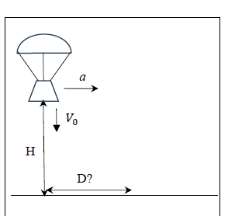
Name:_________________________

6. A landing capsule is descending over the Atlantic Ocean. When it is at height H above the water, it has a velocity Vo that is directed vertically down. Because of the parachutes, the capsule experiences no vertical acceleration. However, the wind causes the capsule to have a constant horizontal acceleration a directed to the right.
a) (10 points) Complete the diagram with all the required information to solve parts b and c.
(OSE) b) (25 points) In terms of system parameters, derive an expression for the distance D the capsule will have traveled horizontally by the time it touches the water.
(OSE) c) (15 points) In terms of system parameters, derive an expression for the velocity just before the capsule touches the water, in unit vector notation. You may use the distance D as a system parameter for this part.

/ 50 for this page

Name:________________________________________
θ

m

rough, μ
frictionless
M, not moving
$$a=⅕ g$$

/ 50 for this page
7. (50 points) A student of mass M is standing on a rough horizontal surface that has a coefficient of static friction µ with the student’s shoes. The student is pulling a box of mass m up a ramp by means of a massless rope that is parallel to the surface and runs over a massless, frictionless pulley. The frictionless ramp makes an angle θ with the vertical. The box is speeding up with an acceleration of magnitude ⅕ g.
a) (10 points) In the figure, superimpose complete free-body diagrams for the student and the box, including all information necessary to solve part b) below.
(OSE) b) (40 points) Derive an expression, in terms of system parameters, for the maximum mass m of the box for which the student can remain at rest.

/ 50 for this page
Name:________________________________________
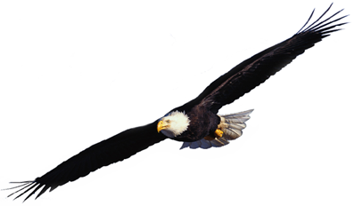
8. (50 points) Birds experience a lift force that is perpendicular to the wings. An eagle is flying in a horizontal circle of radius R at constant speed. The eagle achieves this by tilting his wings at angle θ with respect to the horizontal.
R
θ

a) (10 points) Draw a fully labeled free-body diagram for the eagle, including all information necessary to solve part b).
(OSE) b) (40 points) Derive an expression for the speed of the eagle in terms of system parameters.

/ 50 for this page

