Fall 2024 Physics 1135 Print LAST Name:
Rec Sec Number TEST 3 (4 pages) and First Name:

Test Total = __200___ / 200
For questions on this page, write the letter which you believe to be the best answer in the underlined space provided to the left of the question number. For problems on subsequent pages: your solution to a question with OSE in front of it must begin with an Official Starting Equation. The expression for the final result must be in system parameters and simplified as far as possible. Draw a box around your answer to each question. Neglect air resistance. Calculators and notes cannot be used during the test. If you have any questions, ask the proctor. Put your name on each page.

/ 50 for this page
__D___1. (10 points) S and P are the only forces acting on a rod of length L.
O
P
S
θ
The magnitude of the torque on the rod about its left end at point O is:
A) SL + PL sin θ B) SL + PL cos θ
C) SL D) PL cosθ
_A____2. (10 points) A uniform rod of mass M and length L is pivoted at a point ⅓ L from its end. The moment of inertia with respect to this pivot is
A) $\frac{1}{9}ML^{2}$ B) $\frac{1}{2}ML^{2}$ C) $ML^{2}$ D ) $\frac{7}{48}ML^{2}$

__A___3. (10 points) The position of an object is given by x(t) = A cos(ωt +φ) where t is the time and A, φ and ω are positive constants. Which of the following statements about this object is true?
A) The acceleration of the object always points towards the point x = 0.
B) The magnitude of the acceleration is a maximum when x = 0.
C) The kinetic energy of the object is a minimum when x = 0.
D) The object is momentarily at rest at x= 0.

_B____4. (10 points) A simple pendulum on the surface of the earth has period T. On a distant planet, the length of the pendulum must be doubled to have the same period. The acceleration due to gravity on that planet is
A) 4g B) 2g C) ½ g D) $\sqrt{2}$g
__D___5. (10 points) A mass at the end of a spring is undergoing simple harmonic oscillations. The position of the mass is given by x(t) = A cos(ωt+ϕ). When x(t) = 9m, the mass experiences an acceleration of −16 𝑚/𝑠 ² . What is the angular frequency ω of this system, in s⁻¹ ?
A) 1/2 B) 2/3 C) 9/4 D) 4/3

Name:_________________________________

6. (50 points) A uniform sphere of mass 5M and radius 2R is on an inclined surface that makes an angle θ with the horizontal. A massless string is attached to a massless yoke which is in turn attached to a frictionless axle through the center of the sphere, so that the sphere can rotate about the axle. The other end of the string is wound around a uniform, disk shaped pulley of mass M and radius R, which can rotate on a frictionless axle.
5M
2R
M, R
L
θ
The system is released from rest, and the sphere rolls without slipping down the incline, unwinding the rope from the pulley.
Use energy methods to derive an expression for the linear speed of the sphere when it has traveled a distance L along the incline, in terms of system parameters. Simplify your answer as far as possible.

$$\begin{matrix} & \begin{matrix} & E_{f}-E_{i}= Wother \\ & E_{j}=E_{f} \\ & \frac{1}{2}5{Mv}_{i}^{2}+\frac{1}{2}I_{sp}ω_{isp}^{2}+\frac{1}{2}I_{p}ω_{p}^{2}+5{Mgy}_{i}= \\ & \frac{1}{2}5MV_{f}^{2}+\frac{1}{2}I_{sph}ω_{fsp}^{2}+\frac{1}{2}I_{p}ω_{fp}^{2}+5Mgy_{f} \\ & 5MgLsin⁡θ=\frac{1}{2}5MV_{f}^{2}+\frac{1}{2}\left[\frac{2}{5}5M(2R)^{2}\right]ω_{Sp}^{2}+\frac{1}{2}\left(\frac{1}{2}MR^{2}\right)ω_{p}^{2}\end{matrix} \\ & No slipping: ω_{sp }=\frac{V}{2R}, ω_{p}=\frac{V}{R} \\ & \begin{matrix}5MgL\sin{θ}=\underbrace{\frac{5}{2}}MV_{f}^{2}+MV_{f}^{2}+\frac{1}{4}MV_{f}^{2}=\frac{15}{4}MV_{f}^{2} \\ V_{f}=\sqrt{\frac{4}{3}gLsin⁡θ}\end{matrix}\end{matrix}$$

/ 50 for this page
Name:_________________________________
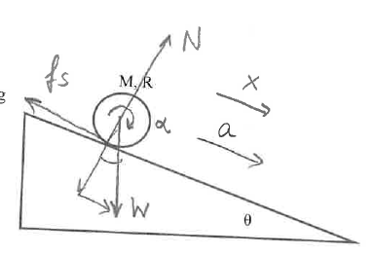
7. (50 points) A uniform disk of mass M and radius R is rolling without slipping down an incline that makes an angle θ with the horizontal.
a) (10 points) Draw an extended free body diagram including all information necessary to solve part b) below.
θ

b) (40 points) (OSE) Use force and torque methods to derive the disk’s linear acceleration.

$$\begin{matrix}\sum{F_{x}}=N_{x}+W_{x}+f_{s+}=Ma_{x} \\ Mgsin⁡θ-f_{s}=Ma_{x} \\ \sum{ }τ_{2}={}_{N_{z}}+{}_{W_{z}}+τ_{f_{z}}=Iα_{z} \\ +f_{s}R=\frac{1}{2}MR^{2}α_{z} \\ \begin{matrix} Noslipping: a=αR \\ fsR=\frac{1}{2}MR^{2}\frac{a}{R} \\ fs=\frac{1}{2}Ma \\ Mgsin⁡θ-\frac{1}{2}Ma=Ma \\ Mgsin⁡θ=\frac{3}{2}Ma \\ a=\frac{2}{3}gsin⁡θ\end{matrix}\end{matrix}$$

/ 50 for this page

Name:_________________________________

/ 50 for this page
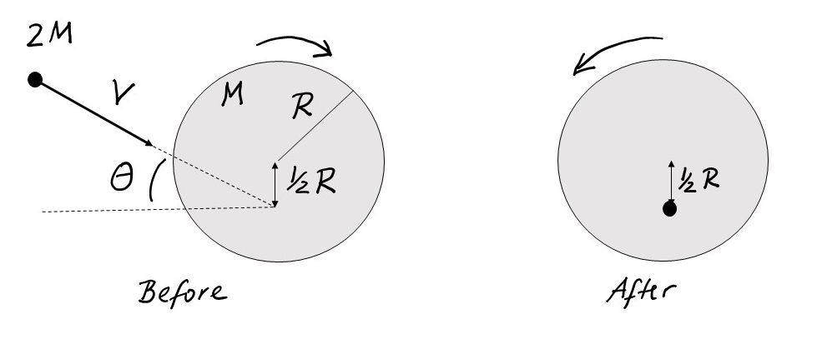
8. (50 points) A large horizontal uniform disk of mass M and radius R is rotating clockwise with unknown angular speed around a frictionless axis that is through its center. At the same time, a small ball of mass 2M is traveling with speed V along a straight path under an angle θ, as shown in the figure. When the ball reaches the point half-way between the center and edge of the disc, it is caught in a massless net attached to the disc, and the direction of rotation reverses but the angular speed is the same as it was initially. You may treat the ball as a point mass.

a) (10 points) Find the total moment of inertia of the disk with the ball caught in the net, in terms of system parameters.
$$\begin{matrix} & I=\underset{\text{disk }}{\underbrace{\frac{1}{2}MR^{2}}}+\underset{\begin{matrix}\text{ ball }= \\ \text{ point mass }\end{matrix}}{\underbrace{2M{\left(\frac{1}{2}R\right)}^{2}}}=\frac{1}{2}MR^{2}+\frac{1}{2}MR^{2}=MR^{2} \\ & \\ & \end{matrix}$$

b) (40 points) (OSE) Derive an expression for the angular speed of the disk, in terms of system parameters.
$$\begin{matrix}\sum{ }\vec{τ_{ext}}=\frac{d\vec{L}}{dt}⇒L_{iz}=L_{fz} \\ I_{\text{divk }}ω_{iz}+l_{\text{ballz }}=I_{disk+ball}ω_{fz} \\ \frac{1}{2}MR^{2}ω-2MVcos⁡θ⋅\frac{1}{2}R=MR^{2}(-ω) \\ \frac{3}{2}MR^{2}ω=MVRcos⁡θ \\ ω=\frac{2Vcos⁡θ}{3R}\end{matrix}$$

