Physics 1135 Version B

Spring 2025 Answer Sheet Print LAST Name:
Rec Sec______ EM Mini-Test First Name:
& Final Exam
Remove this page from your exam when you begin. Write clearly in the space provided on this Answer Sheet the letter which you believe to be the best answer to each question.
.
ONLY THIS ANSWER SHEET will be looked at for scoring. Make sure your chosen answers are on it and do not leave any answer space blank.
Neither calculators nor notes can be used during the test.

Final-Exam Score = 220

EM Mini-Test Score = 70

Mini-Test Responses (10 pts each) Final-Exam Responses (10 pts each)

Em - 1) D 1) D 11) B 21) D
Em - 2) B 2) B 12) A 22) B
Em - 3) A 3) D 13) A
Em - 4) C 4) A 14) C
Em - 5) A 5) B 15) C
Em - 6) C 6) D 16) C
Em -7) __B____ 7) C 17) A
8) B 18) B
9) A 19) D
10) A 20) B

End-Material Mini Test
Em- 1. A wave on a string has a fundamental frequency of 600 Hz. If you press your finger down on the string, shortening its length to 4/5 of the original length, the new fundamental frequency will be
A) 650 Hz B) 480 Hz C) 400 Hz D) 750 Hz

Em- 2. A traveling wave is described by the equation y(x,t) = 3 cm sin(2πx/2.4m -2πt/2.0s). The speed of the wave equals
A) 6 cm/s B) 1.2 m/s C) 6 m/s D) 7.2 m/s

Em-3. An extremely fast bat is flying with a speed that equals ¹/7 the speed of sound directly towards a cliff while generating sound waves of frequency f. What is the frequency of the echo it hears?
A) ⁴/3 f B) ²/3 f C) ⁸/7 f D) ⁷/5 f

k
2k
0ºC
60º C
T?
Em-4. A plastic rod with thermal conductivity k is joined to a metal rod of thermal conductivity 2k. The rods have the same cross section and length. The plastic rod’s end is kept at 0ºC, and the metal rod’s end is kept at 60ºC. What is the temperature at the boundary once steady state is reached?
A) 30 ºC B) 45 ºC C) 40 ºC D) 25 ºC
$3/2$P₀
A
p
V
C
B
4V₀
3P₀
Questions Em-5 through Em-7 refer to the cycle in the figure on the left.

Em-5. A monatomic ideal gas is taken through the cycle A-B-C-A shown in the figure. The change in internal energy going from B to C equals
A) – 9 P_{o}V_{o} B) – 6 P_{o}V_{o}
C) – 12 P_{o}V_{o} D) 6 P_{o}V_{o}

Em-6. A monatomic ideal gas is taken through the cycle A-B-C-A shown in the figure. What is the work done by the gas during the isothermal compression C-A? (There is no mistake in the figure; if you should need the volume at A, you have all information to find it.)
A) 12 P_{o}V_{o} ln 2 B) – 9 P_{o}V_{o} ln 3
C) – 6 P_{o}V_{o} ln2 D) 6 P_{o}V_{o}

Em-7. Which of the following statements about the cycle A-B-C-A in the figure is correct?
A) During one complete cycle, the heat is negative, i.e..heat is flowing out of the gas.
B) The net work done by the gas in the cycle is positive.
C) Negative work is done during the process B-C.
D) The internal energy of the gas increases from C to A.
Final Exam
Ignore air resistance for all problems.

1. A ball is thrown with initial speed 20m/s at 30 ° above the horizontal. When it reaches its maximum height, which quantities are the same as just after launch?
A) acceleration and speed B) speed but not acceleration.
C) vertical component of velocity D) acceleration and horizontal component of velocity

2. An object is moving along the y-axis. The y-component of the object’s velocity as a function of time t is given by $v_{y}\left(t\right)=bt^{2}-c$where b and c are positive constants. Which of the following is true?
A) The object is moving with constant acceleration.
B) The object changes direction at least once.
C) The object is always slowing down.
D) The object is always moving in the negative y-direction

θ
Moving up

M

P
3. A box of mass M is pushed by a horizontal pushing force of magnitude P up a frictionless incline that makes an angle θ with the horizontal. The box speeds up as it is moving up the incline. The acceleration magnitude of the box is
A) g − P/M B) P cos θ/M
C) (P cos θ + Mg sin θ)/M D) (P cos θ − Mg sin θ)/M

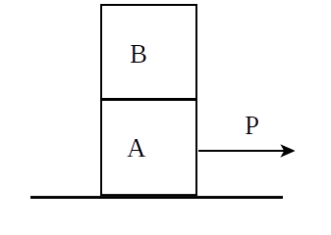
4. Block A is on a frictionless horizontal surface. An identical block B is on top of block A. A constant horizontal force of magnitude P is exerted on block A, pushing it to the right. Block B rides on block A without slipping. The frictional force on block B is:
A) static, to the right B) static, to the left
C) kinetic, to the right D) zero
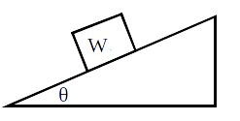
5. A block of weight W is at rest on a rough inclined plane. We know that the magnitude f of the force of static friction satisfies:
A) f = 0 B) 0 < f < W C) f = W D) f > W
6. A box is placed on a horizontal turntable some distance from the axle. The turntable rotates with some speed, and the box does not slip. If the speed of the rotation is then doubled and the box still does not slip, we know that the magnitude of the static friction force has __________ and the coefficient of static friction has_________.
A) doubled, doubled B) increased by a factor of 4, doubled
C) doubled, remained the same D) increased by a factor of 4, remained the same
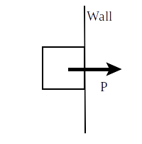
7. You push a box against a vertical wall by applying a horizontal force P. The box is not moving. Now you decrease the push, but not enough for the box to slip. Which of the following forces decrease(s) in magnitude?
A) Friction B) Weight C) Normal force D) Friction and normal force

8. An object connected to a string moves in a circle. The work done by the force of tension in the string is zero because
A) the average of the tension force for each revolution is zero.
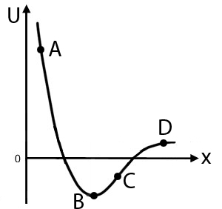
B) at any point, tension force is perpendicular to the velocity.

C) the displacement for each revolution is zero.
D) the object’s speed is constant.

9. A particle is moving along the x-axis under the influence of a conservative force whose potential energy is shown in the figure. At which point is the force directed to the right?
A) A B) B C) C D) C and D

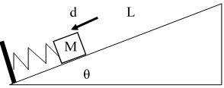
10. A box of mass M is on a frictionless incline that makes an angle θ with the horizontal. The box is placed against a spring of force constant k whose other end is secured to a wall at the lower end of the incline. The block compresses the spring a distance d and is then released from rest. The block comes to a stop after having traveled a distance L along the incline which equals
A) kd ² / (2Mg sin θ) B) kd ² / (2Mg cos θ)
C) kd ² /M D) kd ² /M – 2gd cos θ

11. The free-fall acceleration on planet X is 20 m/s². Planet Z has twice the mass and twice the radius of
planet X. The free-fall acceleration on planet Z equals, in m/s²,
A) 5 B) 10 C) 20 D) 40

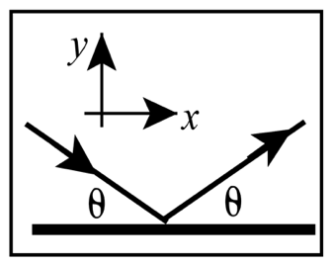
12. The escape speed from a planet of mass 2M and radius R is
A) (4GM/R)^{½} B) (GM/2R)^{½} C) (GmM/R)^{½} D) (GM/R²)^{½}

13. A ball bounces elastically off the floor. The initial speed is equal to the final speed, and the angle of incidence θ equals the angle of reflection, as shown. The x-component of impulse delivered to the ball by the floor is:
A) zero B) negative
C) positive D) not enough information

14. A ball of mass m made of putty moves with speed v. Another ball, of the same mass, chases the first one with speed 2v. Eventually, they collide and stick together after the collision. What is the speed of the combined object?
A) $\frac{1}{2}v$ B) $v$ C) $\frac{3}{2}v$ D) $\frac{3}{2}mv$

15. A large balloon is made of an effectively massless high-tech material. It is then filled with helium of volume V. It floats in the air but is attached to the ground with a massless string. The density of air is ρ_{air}, and the density of helium is ρ_{He}. What is the tension in the string?
A) ρ_{air}Vg B) (ρ_{He} −ρ_{air})Vg C) (ρ_{air} −ρ_{He})Vg D) ρ_{He}Vg

16. A rotating disk has a blue dot painted on its outer edge and a red dot halfway between center and edge. Which of the following is true?
A) Both dots have the same linear velocity.
B) The blue dot has a larger angular velocity than the red dot.
C) Both dots have the same angular velocity.
D) The red dot has a larger angular velocity than the blue dot.

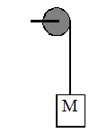
17. What is the moment of inertia of a uniform rod of mass M and length L that is pivoted at a point ⅓ L from its end? (The moment of inertia of the rod is ML²/12 about its center of mass and ⅓ML² about its end.)
A) (1/9) ML² B) (5/9) ML² C) (13/36) ML² D) (7/36) ML²
18. A mass M is hung by a string wrapped around a pulley. The pulley has a radius R and a moment of inertia about its center of mass I = ½ MR². The pulley rotates on a frictionless axle, and the string does not slip on the pulley. The magnitude of the acceleration of the mass as it descends equals:
A) ³/2 g B) ⅔ g C) g D) ½ g

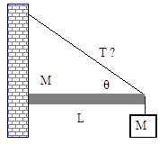
19. A stationary horizontal bar of mass M and length L is attached to a wall at its left end and supported by a cable at its right end. The cable makes an angle θ with respect to the horizontal. A block with the same mass as the bar is hanging from the right end. The magnitude of the tension in the cable is
A) 2Mg/sin θ B) 3MgL C) 3Mg/(2cos θ) D) 3Mg/(2sin θ)

20. A figure skater is rotating about her own axis with some angular speed ω with her arms on her body. She then stretches her arms out. As a result, her angular speed is
A) reduced because friction between her skates and the ice is increased
B) reduced because her moment of inertia is increased
C) increased because her moment of inertia is increased
D) increased because she is doing work

21. A block is on a frictionless surface and is attached to a fixed horizontal spring. The block is pulled away from the equilibrium position of the spring, thereby stretching the spring, and released from rest. When the block passes through the equilibrium position after release, what is true about its speed and the magnitude of its acceleration?
A) Both are at minimum. B) Speed is minimum, acceleration magnitude is maximum.
C) Both are at maximum. D) Speed is maximum, acceleration magnitude is minimum.

22. An object is undergoing simple harmonic oscillations with amplitude A. At what displacement from the equilibrium position does its kinetic energy equal three times its potential energy?
A) ⅓ A B) ½ A C) ⅔ A D) A

The Physics 1135 instructors wish you a wonderful summer!

