Spring 2025 Physics 1135 Print LAST Name:
Rec Sec Number TEST 2 (4 pages) and First Name:

Test Total = 200 / 200
For questions on this page, write the letter which you believe to be the best answer in the underlined space provided to the left of the question number. For problems on subsequent pages: your solution to a question with OSE in front of it must begin with an Official Starting Equation. The expression for the final result must be in system parameters and simplified as far as possible. Draw a box around your answer to each question. Neglect air resistance. Calculators and notes cannot be used during the test. If you have any questions, ask the proctor. You must put your name on each page of the test.

50 / 50 for this page
__C_____1. (10 points) A cylinder of height H and base area A with uniform density is floating upright in water. Half of the cylinder remains above the waterline. The buoyancy force is B. The difference between the pressure at the cylinder’s lower surface and the atmospheric pressure at the water surface equals
A) B B) ½ B C) B/A D) ½ B/A
__B_____2. (10 points) A U-shaped tube open to air at both ends is partially filled with water of density ρ. Oil is then poured into the left arm until it forms a column of height L and the surface of the oil is a distance h higher than the surface of the water. The density of the oil equals
Water
air
air
L
h
Oil
A) ρ $\frac{h}{L}$ B) ρ (1- $\frac{h}{L}$) C) ρ $\frac{L}{h}$ D) ρ (1- $\frac{L}{h})$

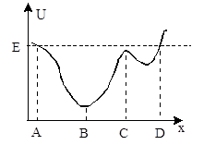
__D_____3. (10 points) An object has mechanical energy E and moves in the one-dimensional potential U(x) shown in the figure. Which is true?
A) The force points in the negative x-direction at point A.
B) The object is at rest at point B.
C) The object is in stable equilibrium at point C.
D) The object is at rest at point D.

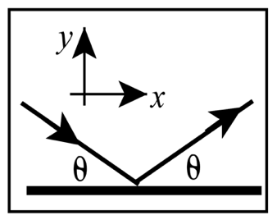
___B____4. (10 points) Which of the following planets with mass ____ and radius___has the largest free-fall acceleration?
A) M,R B) 2M, R C) M, 2R D) 2M, 2R
___A____5. (10 points) A ball bounces elastically off a wall. The initial speed is equal to the final speed and the angle of incidence θ equals the angle of reflection, as shown. The x-component of impulse delivered to the ball by the wall is:
A) zero B) negative
C) positive D) not enough information
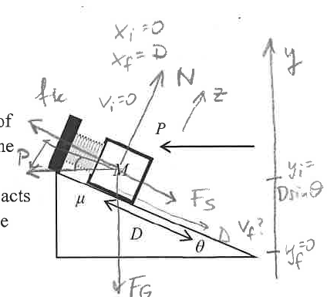
Name:_________________________
6. (50 points) A block of mass M on a rough incline is attached to a spring of force constant k. The other end of the spring is fixed to the wall. The incline makes an angle θ with the horizontal, and the coefficient of kinetic friction between block and incline is μ. A horizontal force of constant magnitude P acts on the block throughout its motion. The block is released from rest when the spring is at its equilibrium position. The block moves down the incline, stretching the spring.
a) (10 points) In the diagram, add all information needed to solve part b below. Include a free-body diagram for the block.

b) (OSE) (40 points) Use energy methods to derive an expression for the speed of the block when it has moved a distance D.
$$\begin{matrix} & E_{f}-E_{i}=W_{other} \\ & \frac{1}{2}MV_{f}^{2}+Mgy_{f}+\frac{1}{2}kx_{f}^{2}-\frac{1}{2}MV_{i}^{2}-Mgy_{i}-\frac{1}{2}kx_{i}^{2}=W_{N}+W_{p}+W_{f}=-PD\cos{θ}-μND\end{matrix}$$

Find N:
$$\begin{matrix}\sum{ }F_{z}=N_{z}+P_{z}+F_{G_{z}}+f_{gx}+F_{sz}={ma}_{z} & \\ N-Psin⁡θ-μgcos⁡θ & =0 \\ N & =Psin⁡θ+Mgcos⁡θ\end{matrix}$$

$$\begin{matrix}\frac{1}{2}mv_{f}^{2}+\frac{1}{2}kD^{2}-MgDsin⁡θ=-PDcos⁡θ-μ(Psin⁡θ+Mgcos⁡θ)D \\ v_{f}=\sqrt{\frac{2}{M}\left[MgDsin⁡θ-PDcos⁡θ-μ(Psin⁡θ+Mgcos⁡θ)D-\frac{1}{2}kD^{2}\right]}\end{matrix}$$

50 / 50 for this page
Name:_________________________

7. (50 points) A spaceship of mass m is moving in a circular orbit a distance R above the surface of a planet of mass 2M and radius 2R as shown in the figure.
R
2R
m
a) (5 points) Superimpose a free body diagram for the spaceship with all the information necessary to solve parts b).
2M
b) (OSE) (25 points) Derive a symbolic expression for the period T of the spaceship in terms of system parameters.
$$\begin{matrix} & \sum{ }F_{x}=F_{G_{x}}=ma_{x} \\ & \frac{G2Mm}{(3R)^{2}}=m\frac{v^{2}}{3R} v=\frac{2π(3R)}{T} \\ & \frac{2GM}{3R}=v^{2}=\frac{4π^{2}(3R)^{2}}{T^{2}} \\ & T=\sqrt{\frac{4π^{2}(3R)^{3}}{2GM}}=\sqrt{\frac{54π^{2}R^{3}}{GM}}\end{matrix}$$

c) (OSE) (20 points) In terms of system parameters, derive an expression for the speed the spaceship needs in order to escape from this orbit into deep space.
$$\begin{matrix}E_{f}-E_{i} & =W_{other} \\ E_{i} & =E_{f} \\ \frac{1}{2}mv_{esc}^{2}- & \frac{G2Mm}{3R}=\frac{1}{2}mp_{f}^{2}-G\frac{2Mm}{r_{∞}} \\ v_{esc} & =\sqrt{\frac{4GM}{3R}}\end{matrix}$$

50 / 50 for this page

Name:________________________________________
8. (50 points) A firecracker of mass M moves with speed V in a straight line that makes an angle θ with the y-direction, as shown in the diagram. It explodes and breaks up into two fragments of unequal masses. Fragment A of mass ¼ M moves with speed ½V in the positive x-direction.
M
¼M

V
θ
x
y
before
after
¾M
½V
Fragment B moves with an unknown velocity.
In terms of relevant system parameters, derive an expression for the velocity of fragment B in unit vector notation.

$$\begin{matrix}{\vec{J}}_{\text{n}\text{et }\text{ext} }^{}={\vec{P}}_{f}-{\vec{P}}_{i} \\ P_{ix}=P_{fx} \\ MVsin⁡θ=\frac{1}{4}M\frac{1}{2}V+\frac{3}{4}MV_{Bx} \\ V_{Bx}=\frac{4}{3}\left(\operatorname{Vsin}{θ}-\frac{1}{8}V\right) \\ P_{iy}=P_{fy} \\ -MVcos⁡θ=0+\frac{3}{4}MV_{By} \\ V_{By}=-\frac{4}{3}Vcos⁡θ \\ {\vec{V}}_{B}=\frac{4}{3}V\left(sin⁡θ-\frac{1}{8}\right)\overset{ˆ}{1}-\frac{4}{3}Vcos⁡θ\overset{ˆ}{ȷ}\end{matrix}$$

50 / 50 for this page

